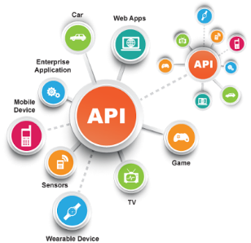**SE495 Software and Systems Integration**

**Chapter 1: Introduction - Guided Project: Building a Simple Integration between Two Applications**

*Objective*: In this guided project, students will explore the basics of systems integration by creating a simple integration between two applications using RESTful APIs.

*Requirements*:

* Basic understanding of Python programming
* Familiarity with HTTP requests and RESTful APIs

*Tools and Technologies*:

* Python 3.x
* requests library in Python

**Step-by-step guide**:

1. **Select two applications**: Choose two applications with available RESTful APIs that you want to integrate. For instance, you can select a task management system like Trello and a communication platform like Slack. The objective here will be to send a message to a Slack channel when a new task is created in Trello.
2. **Create API keys**: Sign up for developer accounts on both platforms (Trello and Slack) and generate the necessary API keys and access tokens.
3. **Install the requests library**: In your Python environment, use the following command to install the requests library:

pip install requests

```

1. **Set up API endpoints**: Identify the API endpoints for the operations you want to perform. For example, to get a list of Trello boards, you can use the following endpoint:

https://api.trello.com/1/members/me/boards?key={apiKey}&token={apiToken}

```

And to send a message to a [Slack](poe://www.poe.com/_api/key_phrase?phrase=Slack&prompt=Tell%20me%20more%20about%20Slack.) channel, you can use this endpoint:

<https://slack.com/api/chat.postMessage>

1. **Create a Python script**: Write a Python script that uses the requests library to perform the following actions:

a. Fetch the list of Trello boards and display them to the user.

b. Allow the user to select a Trello board and then fetch the corresponding lists from that board.

c. Allow the user to create a new task in a selected list.

d. Once the task is created, send a message to a Slack channel with the details of the new task.

1. **Test the integration**: Run the Python script and verify if the integration is working as expected. Make sure that the new task is created in Trello and the corresponding message is sent to the Slack channel.